Basic Pratice of Programming Meeting 1



From:
AL AZHAR RIZQI RIFA’I FIRDAUS
Class:
1 I
Absence:
01
Major:
Information Technology
Study Program:
Informatic Engineering
Experiment 1: Installing the Java Development Kit/JDK
Screenshoot java binary at file bin
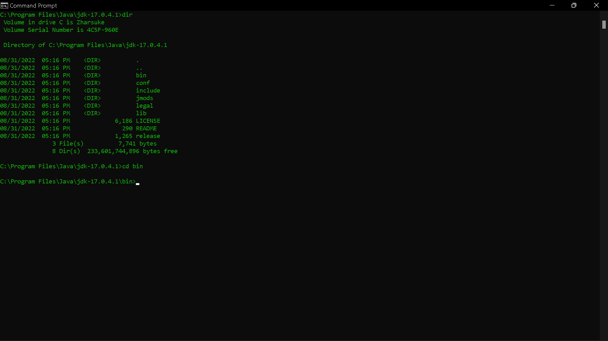

Screenshoot path env location
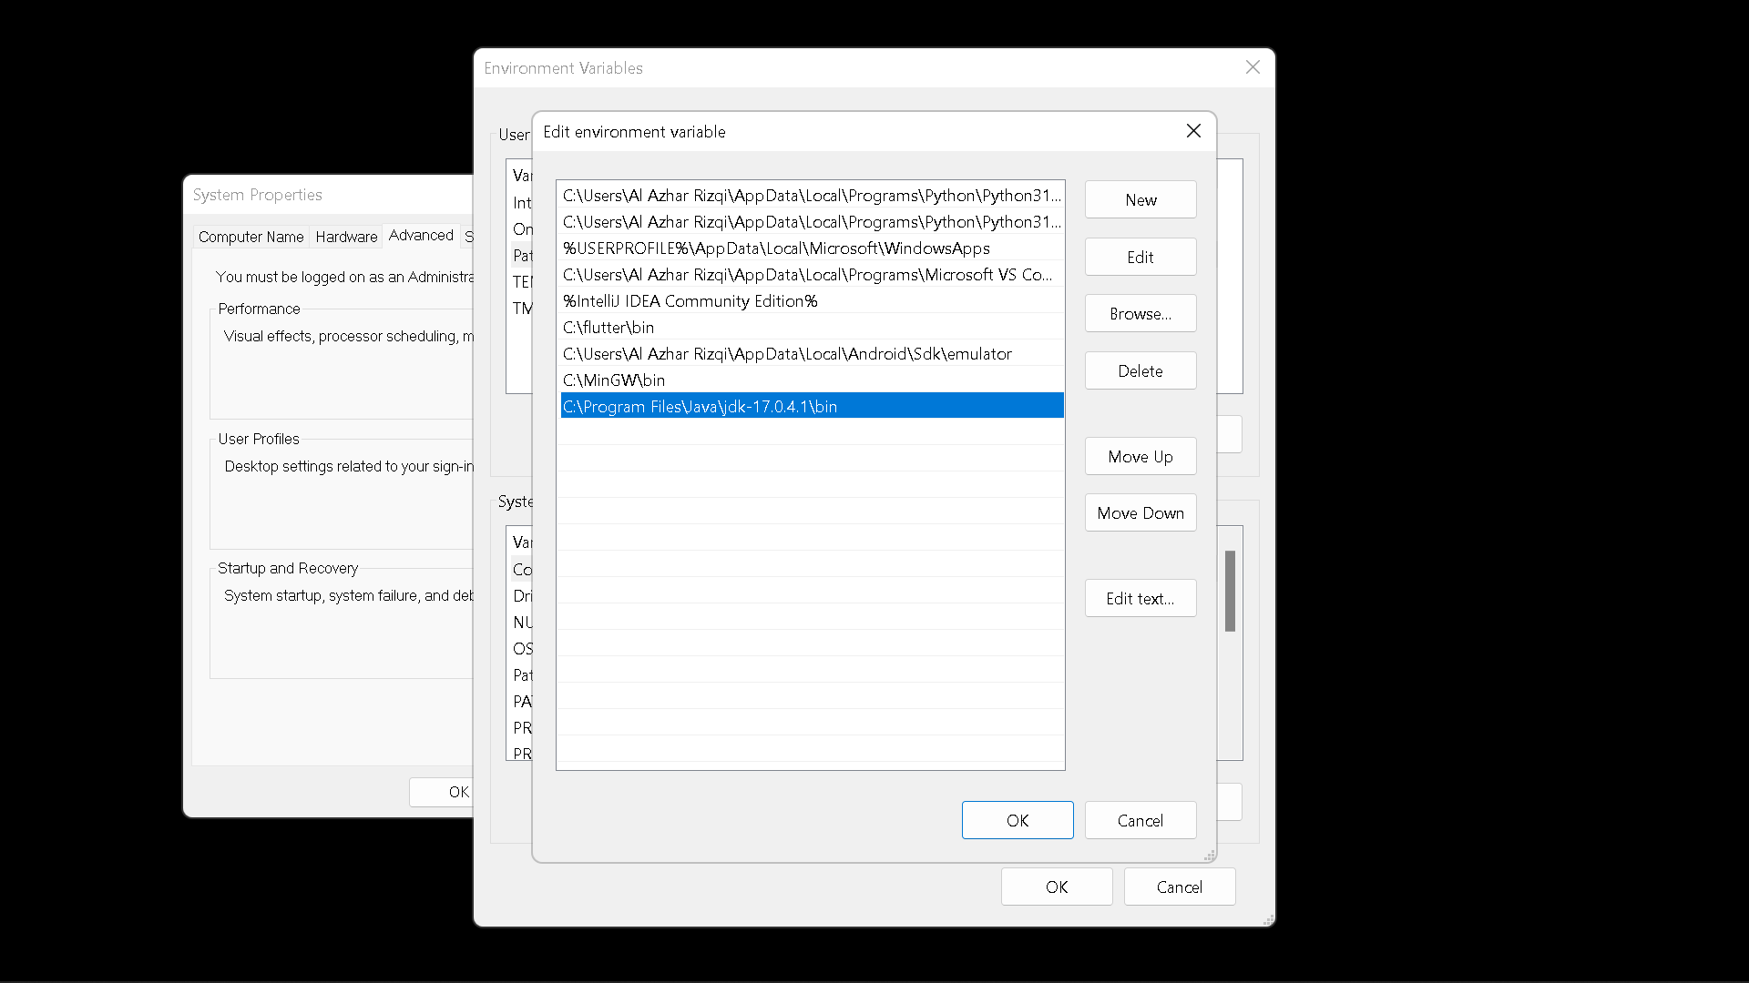

Screenshoot running javac
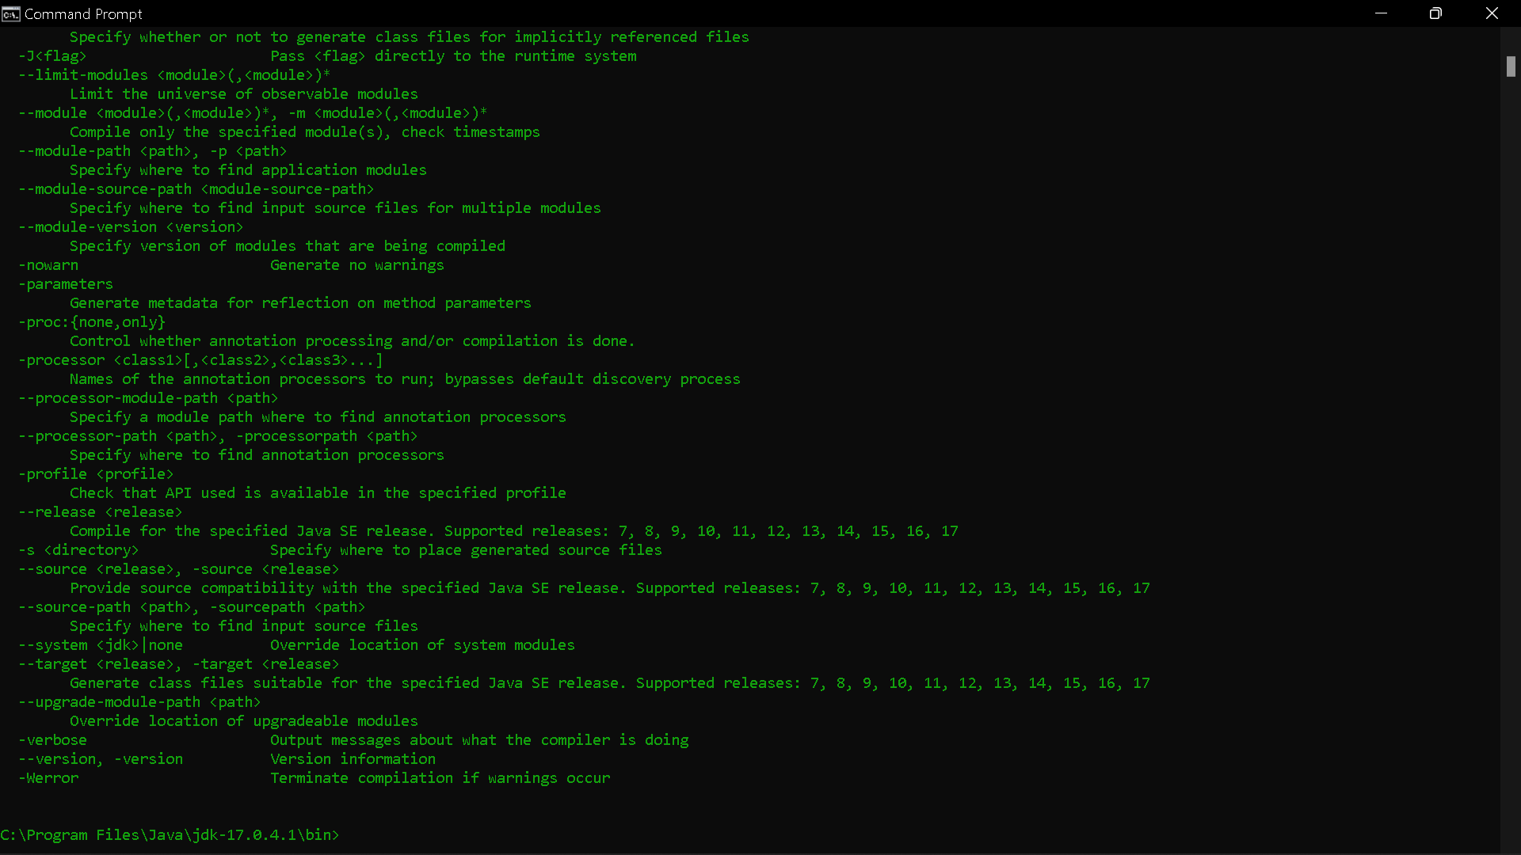

Questions
1. Explain the use of entering the location of the Java bin folder into the PATH!
2. Explain the use of the javac command when entering the command prompt!
Answer
- To put the directories who want to search when do command at command prompt.
- Javac is one of binary file at jdk to compile file .java to .class file which one will be execute again with “java” command.

Experiment 2: Basic Structure of Java
Screenshoot file MyFirstJava00.java
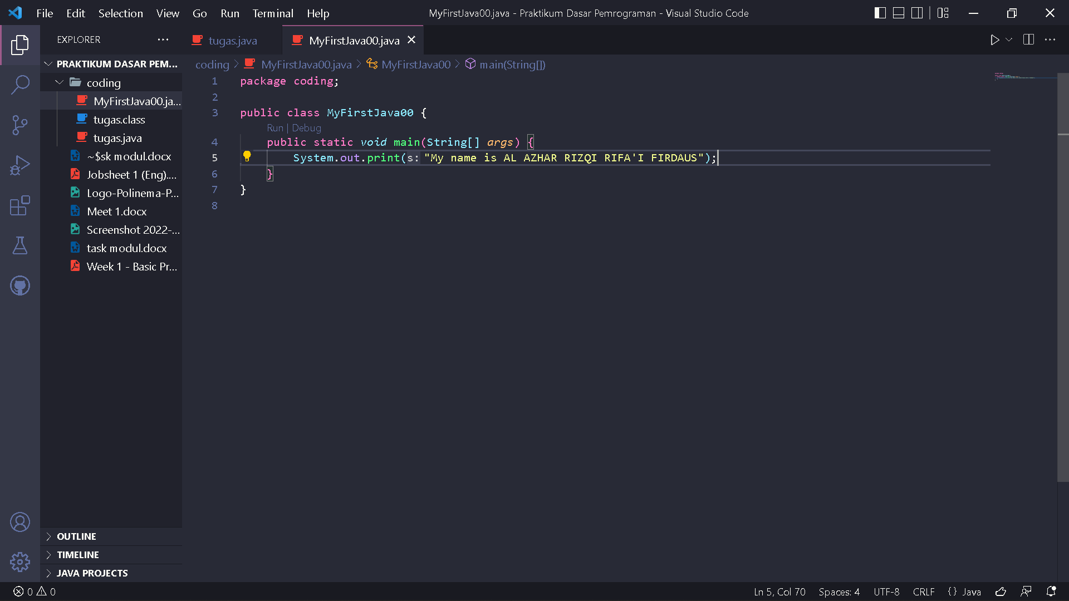

Screenshoot output file MyFirstJava00.java
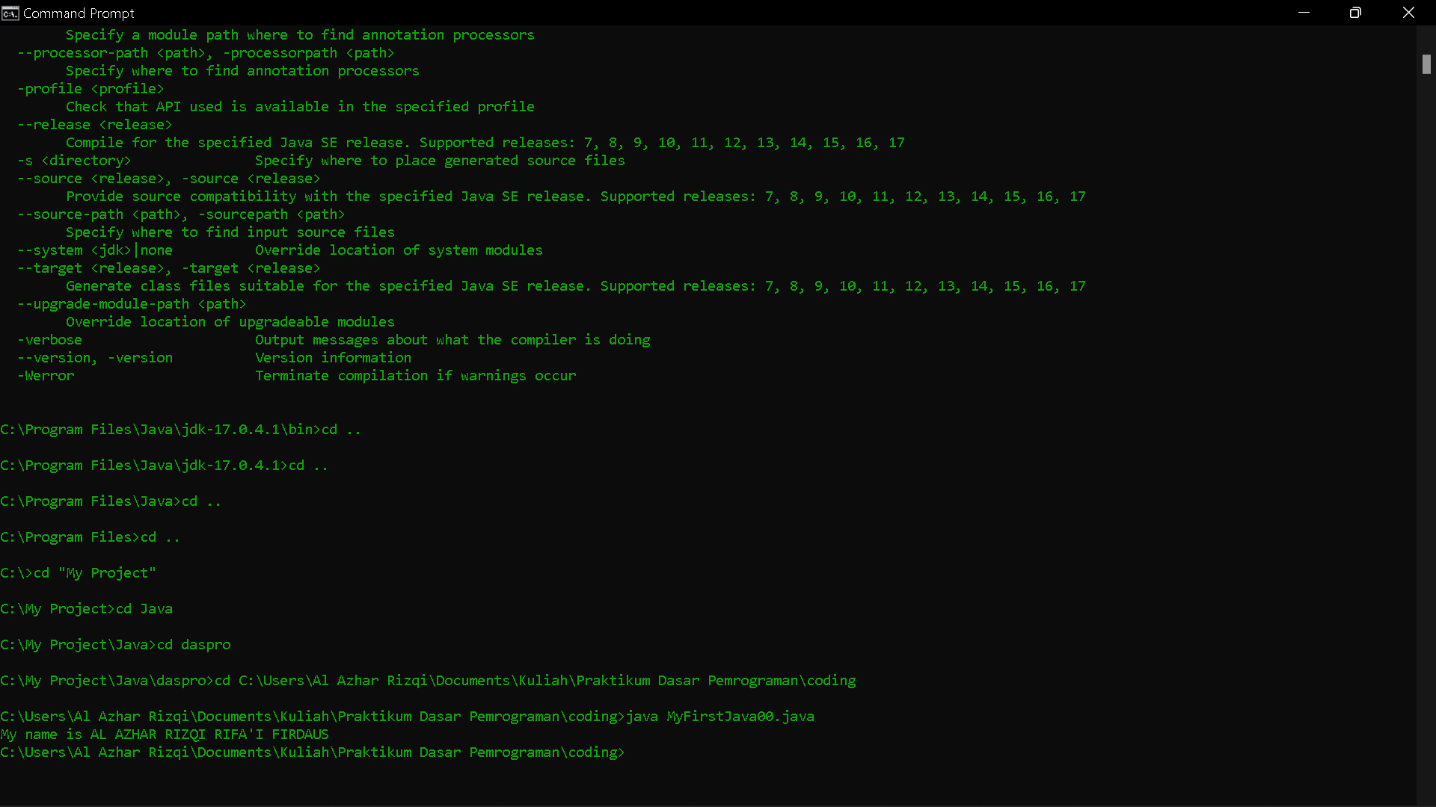

Questions!
1. Explain the function of javac MyFirstJava00.java command in the experiment!
2. Explain the function of java MyFirstJava00 command in the experiment!
3. Add the program code System.out.println("I am a Student of Informatics Engineering Program"); on line 6, then run the program and explain how the output is!
Code :
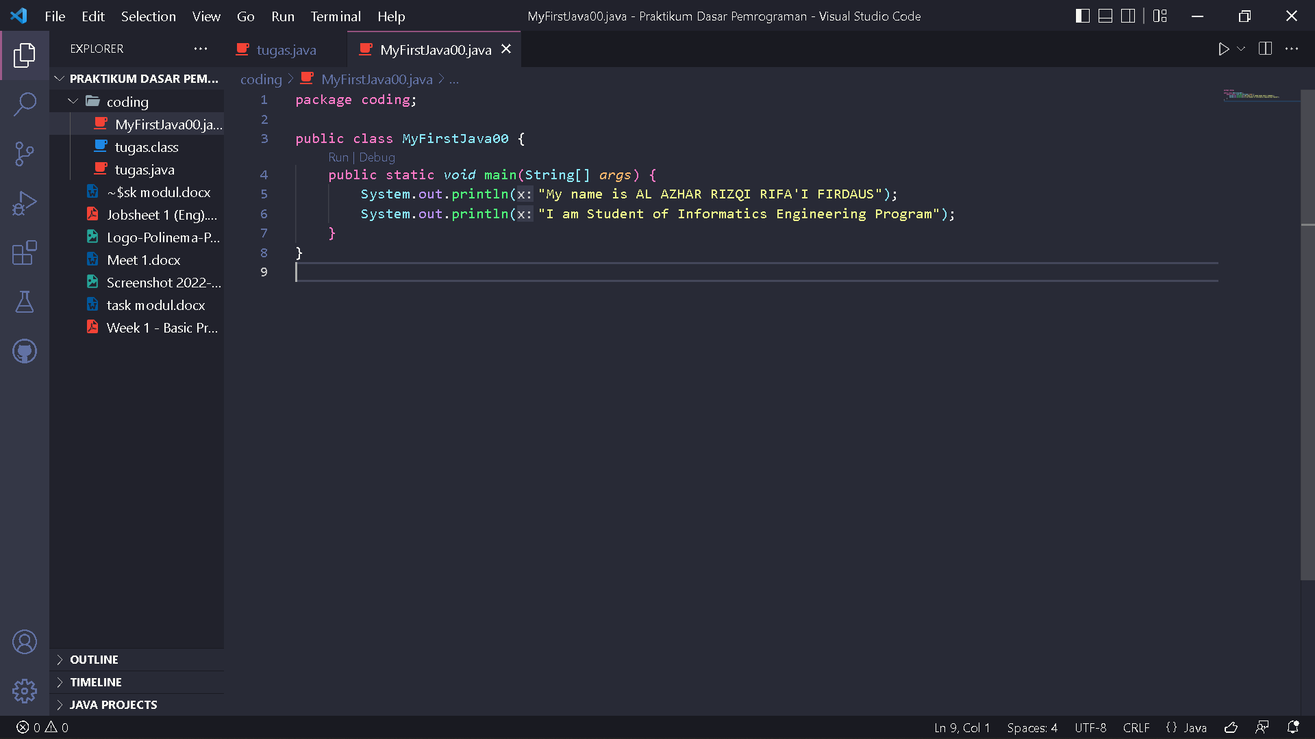
Output :
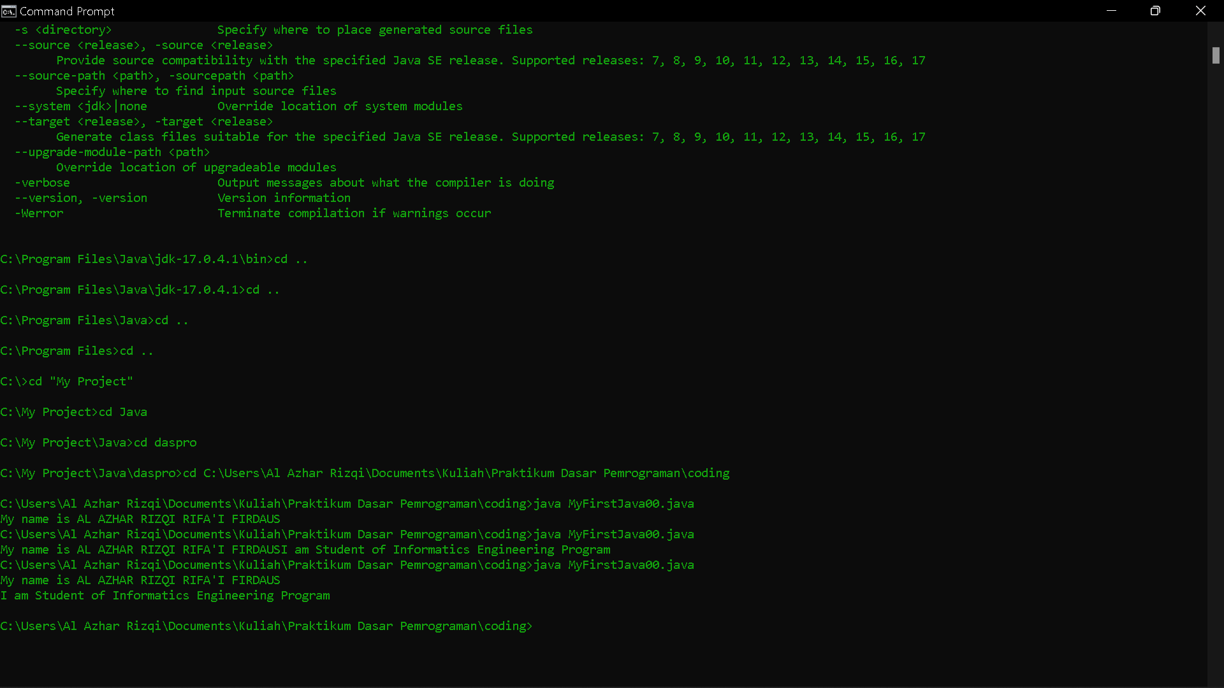

Explanation
With add statement :
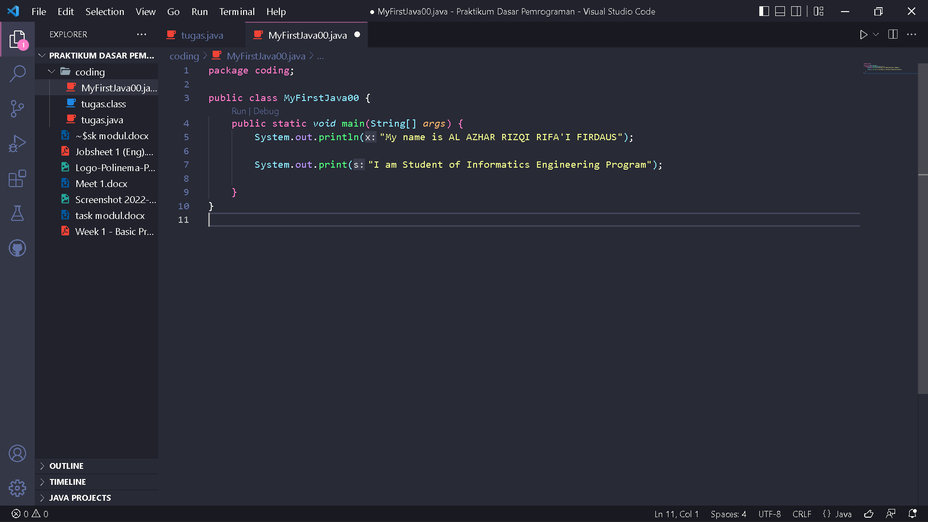
Output will display “I am Student of Informatics Engineering Program”
4.Code :
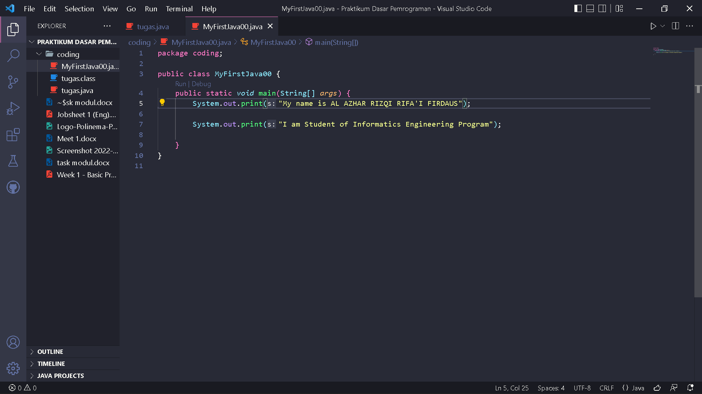
Output :
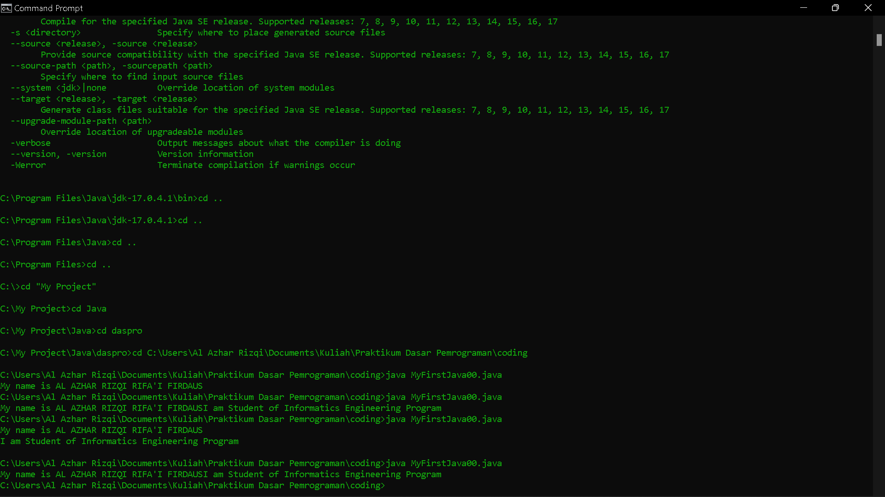
5. The difference between
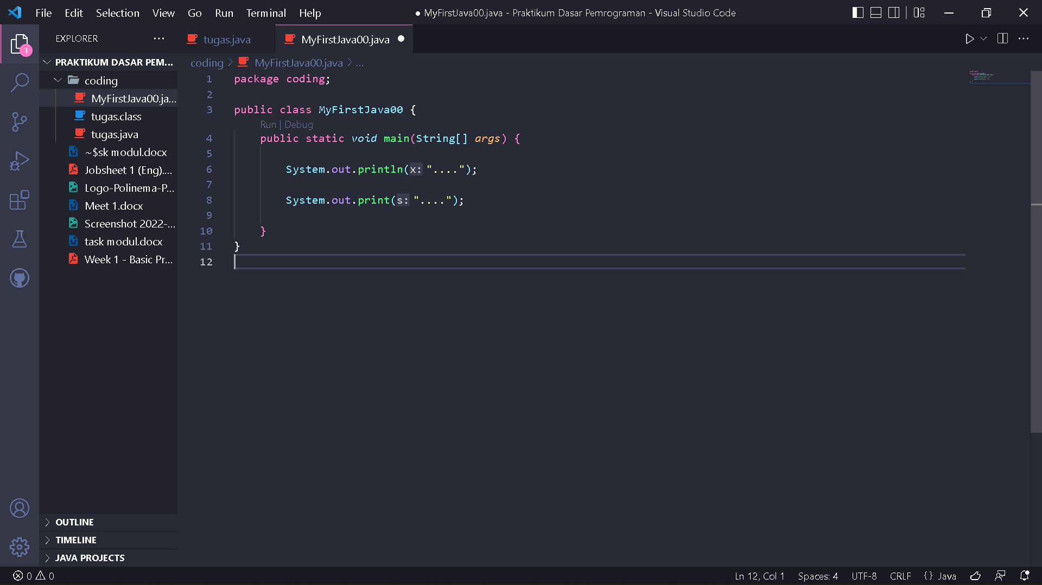
With

Is on adding enter to the output where ‘println’ add enter at the end of its output and ‘print’ does not.
6. Code :
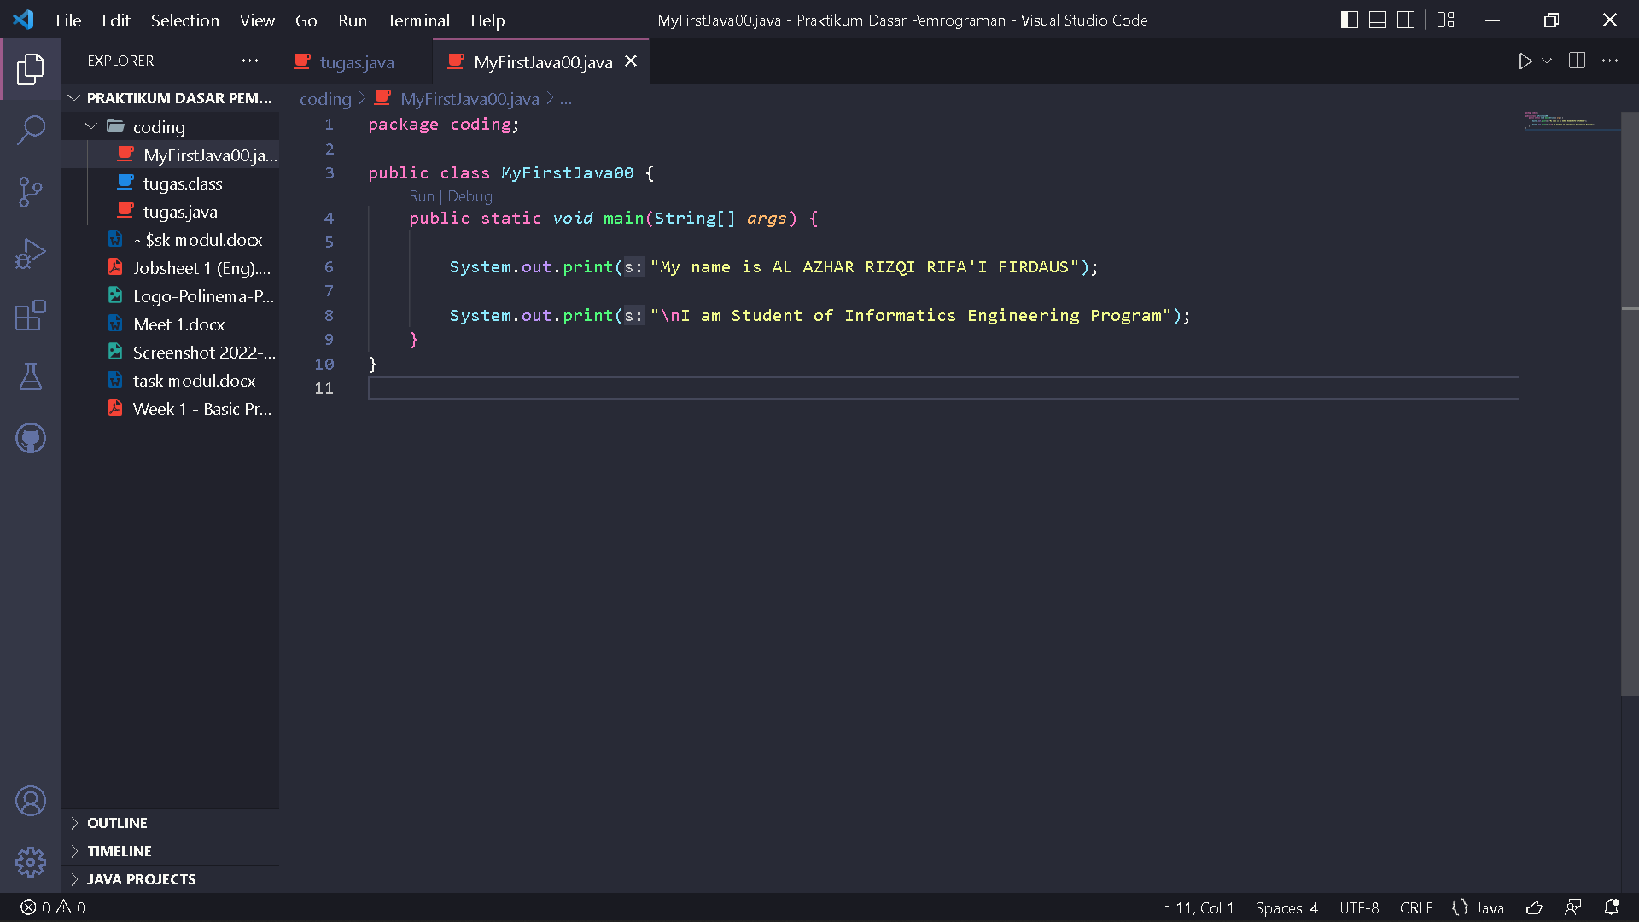
7. The function symbol \n to add enter newline at output.
8. Code :
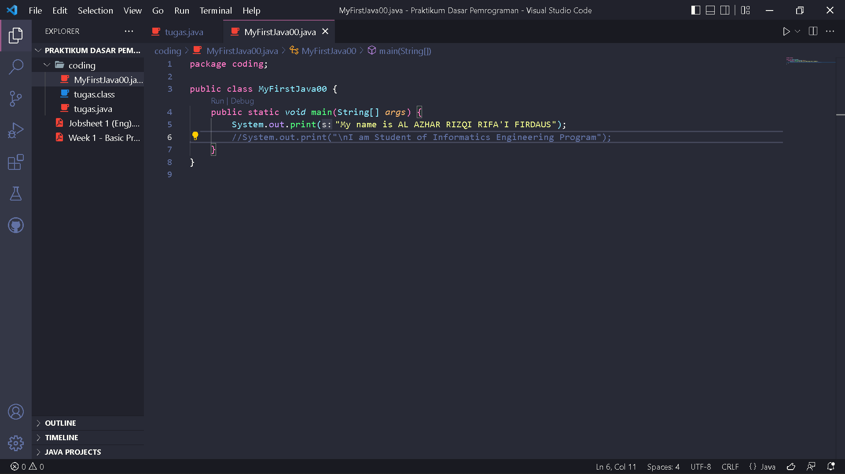
9. Program observation
10. The function from // symbol to give comment at code useful to give description with human language at code too much and too complicated.

Assignment
Code :
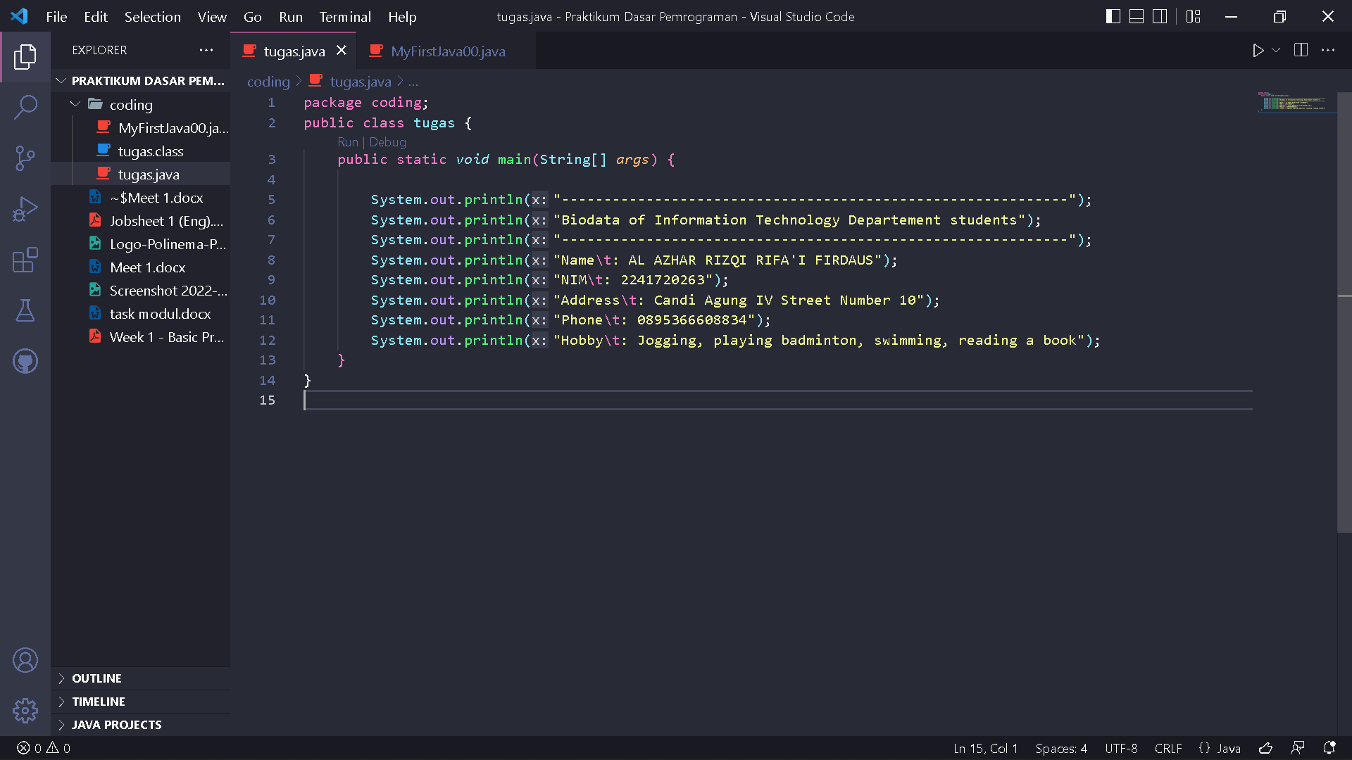
Output :
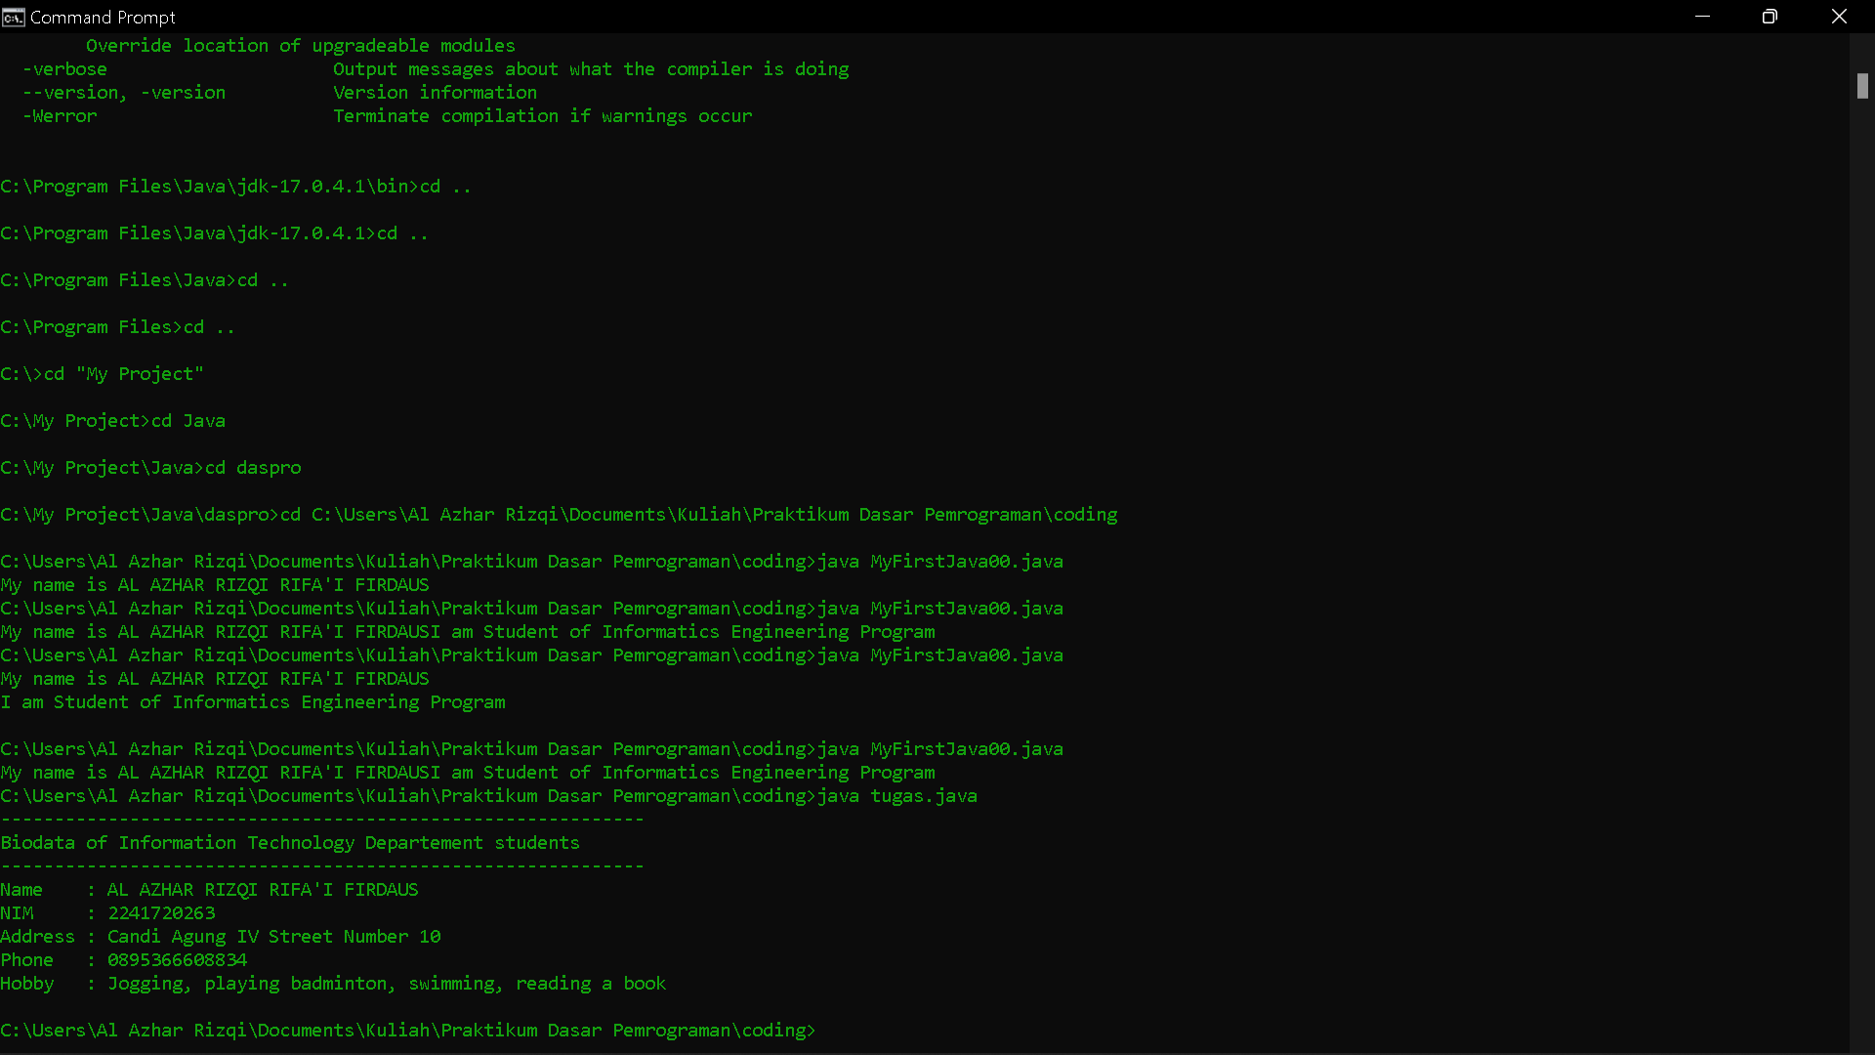
Explanation :
The above program aims to display output in the form of your own identity, which uses the statement System.out.println() as a means of outputting the terminal.

